Air Quality Monitoring System with ESP32-C3, DHT22 and MQ-135
This project uses an ESP32-C3 Super Mini board, a DHT22 temperature/humidity sensor, and an MQ-135 air quality (multi-gas) sensor. The ESP32-C3 reads both sensors periodically, then publishes the data via MQTT to a broker for visualization on a dashboard. The system can run on battery (using deep sleep to save power) or on external power. Below are detailed hardware specs, wiring, firmware code, MQTT server setup (local and cloud), data format, and visualization steps.

Hardware Components
- ESP32-C3 Super Mini: A 16-pin WiFi/Bluetooth (BLE) microcontroller board with a 32-bit RISC-V core up to 160 MHz. It operates at 3.3 V logic and can be powered by USB-C (5 V) or VIN (3.3–6 V)[1]. It features 11 usable GPIOs (with 6 ADC channels)[1][2] and an onboard LED on GPIO8 (active-low). In deep-sleep mode it draws ~43 µA[1] (though measured values can be ~600 µA with the LED on[3]). The board includes 4 MB flash, 400 KB SRAM, and supports PWM, UART, I²C, and SPI interfaces[4][5].
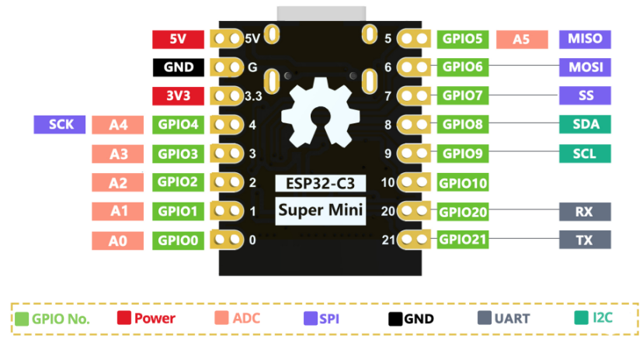
Figure: ESP32-C3 Super Mini pinout (3.3 V logic, 5 V input, ADC channels on GPIO0–5)[1][6].
- DHT22 (AM2302) Sensor: A digital humidity and temperature sensor. It is powered from 3.3–5 V[7] and outputs temperature (-40…80 °C, ±0.5 °C) and humidity (0–100 %RH, ±2 %) over a one-wire serial interface[7]. The DHT22 module includes a microcontroller that does analog-to-digital conversion, so it sends a calibrated digital signal over a single data line. Its data line requires a pull-up resistor (typically 4.7–10 kΩ)[8]. The sensor draws about 1–2 mA during measurement[9]. In practice, connect VCC to 3.3 V, GND to ground, and DATA to any ESP32 GPIO.
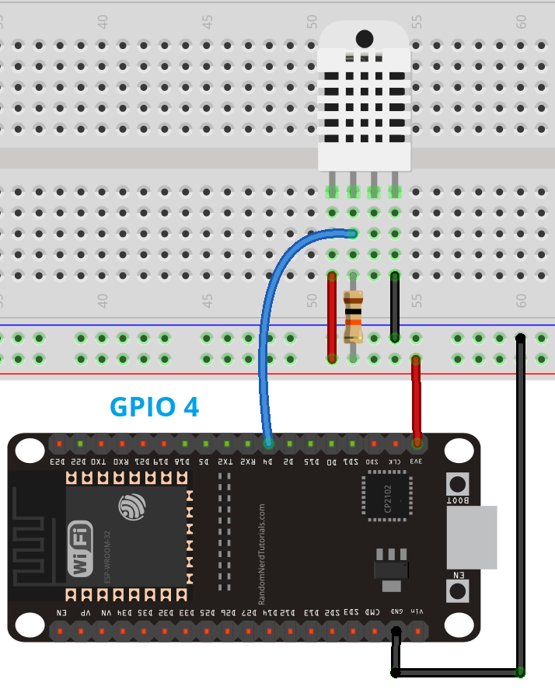
Figure: Wiring diagram for DHT22 (10 kΩ pull-up from data to VCC). Connect DHT22 VCC→3.3 V, GND→GND, DATA→ESP32 GPIO (e.g. GPIO4)[8].
- MQ-135 Air Quality Sensor: An analog gas sensor sensitive to CO₂, NH₃, alcohol, smoke, etc. The sensor (heater) requires ~5 V and draws ≈150 mA[10][11]. The MQ-135 breakout board provides an adjustable analog output (AO) and a digital output (DO) comparator. With a 5 V supply, AO yields 0–5 V proportional to gas concentration[11]. The breakout’s DO can be set via a potentiometer. For our ESP32 (3.3 V ADC), it’s safest to power the MQ-135 at 3.3 V (giving 0–3.3 V output) or use a voltage divider if using 5 V. The MQ-135 module’s key specs are: operating voltage 2.5–5.0 V, heater consumption ~150 mA, analog output 0–5 V (at 5 V supply)[11]. Connect MQ-135 VCC to 5 V (or 3.3 V), GND to ground, and AO to an ESP32 ADC pin.

Wiring and Pin Connections
Use the ESP32-C3 GPIO pins as follows:
- DHT22: VCC→3.3 V, GND→GND, DATA→GPIO4 (or any free digital I/O). Add a 10 kΩ pull-up from DATA to 3.3 V if the module lacks one[8]. (GPIO4 is ADC-capable but used here as digital input.)
- MQ-135: VCC→5 V (or 3.3 V), GND→GND, AO→GPIO0 (ADC1_CH0). Any ADC-capable pin (GPIO0–5) can be used[6]. If powering at 5 V, use a voltage divider on AO (e.g. a 2:1 divider) to ensure the ADC sees ≤3.3 V. Alternatively, supply the MQ-135 with 3.3 V to match ESP32 logic (at reduced sensor sensitivity).
The ESP32-C3’s analog-input pins are GPIO0–5[6]. Example pinout table for wiring:
- ESP32 3.3V pin → DHT22 VCC.
- ESP32 GND → DHT22 GND and MQ-135 GND.
- ESP32 GPIO4 → DHT22 DATA (with 10 kΩ pull-up)[8].
- ESP32 GPIO0 (ADC) → MQ-135 AO (analog output)[11][6].
- ESP32 5V pin (USB VIN) → MQ-135 VCC (heater), or use a separate 5 V supply.
These connections match the modules’ requirements[8][11]. Be careful not to use the ESP32 strapping pins (GPIO2, GPIO8, GPIO9) for general I/O, as they affect boot mode[12].

Firmware (PlatformIO Code)
Use PlatformIO with the espressif32 platform and esp32-c3-devkitm-1 board (Arduino framework). Include the necessary libraries: WiFi.h, PubSubClient.h (for MQTT), and a DHT library (e.g. Adafruit DHT)[13]. The platformio.ini might contain:
[env:esp32-c3-devkit]
platform = espressif32
board = esp32-c3-devkitm-1
framework = arduino
Example Arduino-style code outline:
#include <WiFi.h>
#include <PubSubClient.h>
#include <DHT.h>
#define DHTPIN 4 // DHT22 data pin
#define DHTTYPE DHT22
#define MQPIN 0 // MQ-135 analog pin (GPIO0)
const char* ssid = "your_SSID";
const char* password = "your_WIFI_password";
const char* mqttServer = "192.168.1.100"; // Local broker IP or cloud address
WiFiClient espClient;
PubSubClient client(espClient);
DHT dht(DHTPIN, DHTTYPE);
void setup() {
Serial.begin(115200);
dht.begin();
WiFi.begin(ssid, password);
while (WiFi.status() != WL_CONNECTED) { delay(500); } // wait for Wi-Fi
client.setServer(mqttServer, 1883);
}
void loop() {
if (!client.connected()) {
// Reconnect (add code for authentication if needed)
client.connect("esp32Client");
}
client.loop();
// Read sensors
float h = dht.readHumidity();
float t = dht.readTemperature();
int mqValue = analogRead(MQPIN);
// Optional: convert raw analog to ppm or voltage
// e.g.: float mqVolts = mqValue * (3.3 / 4095.0);
if (!isnan(h) && !isnan(t)) {
// Format payload (JSON example)
String payload = "{";
payload += "\"temperature\":" + String(t,1) + ",";
payload += "\"humidity\":" + String(h,1) + ",";
payload += "\"gas_raw\":" + String(mqValue);
payload += "}";
client.publish("home/air", (char*) payload.c_str());
}
// Sleep for interval (e.g. 60 sec)
delay(60000);
// For battery: use deep sleep instead of delay (see below)
}
This code connects to Wi-Fi, then to the MQTT broker. It reads the DHT22 (dht.readHumidity(), dht.readTemperature()) and the MQ-135 analog value (analogRead(MQPIN)). Data is published to topic (e.g. home/air) in JSON format. You can adjust topics or payload format as needed. The example publishes a JSON string, but you could also publish separate MQTT topics (e.g. home/temperature, home/humidity, home/gas). Avoid exposing raw JSON on a user interface – use the dashboard to parse and display values.
For power saving on battery, replace delay() with deep sleep: after publishing, call:
esp_sleep_enable_timer_wakeup(60000000ULL); // sleep 60 seconds
esp_deep_sleep_start();
This puts the ESP32-C3 into low-power mode (~40–600 µA)[1][3]. On wake-up it will run setup() again. Note: the DHT22 needs ~2 s to start up after power, so add a short delay before reading after wake-up. Also disable the onboard LED in code for lowest power (since it’s active LOW on GPIO8).

MQTT Server Setup
You can use Eclipse Mosquitto as the MQTT broker. Local (LAN) Setup: On a Linux/Raspberry Pi or desktop, install Mosquitto (sudo apt-get install mosquitto mosquitto-clients). By default it listens on port 1883 and usually allows anonymous connections for testing[14]. In /etc/mosquitto/mosquitto.conf, you can specify:
allow_anonymous true
listener 1883
for initial testing[14]. After testing, secure it by adding a password file and disabling anonymous access:
allow_anonymous false
password_file /etc/mosquitto/passwd
(restart Mosquitto after changes)[15]. Ensure your firewall allows port 1883.
For cloud-based operation, you could run Mosquitto on a cloud VM (e.g. AWS EC2, Azure VM) or use a managed MQTT service (HiveMQ Cloud, CloudMQTT, AWS IoT Core, etc.). In that case use the cloud broker’s host/IP and credentials in your ESP code (update mqttServer, and possibly add client.connect() with username/password). Use TLS if available for security.
Once Mosquitto is running, test with the Mosquitto client tools:
- Subscribe: mosquitto_sub -h localhost -t "home/#"
- Publish test: mosquitto_pub -h localhost -t "home/air" -m "{\"test\":1}"

Data Format and Visualization
The ESP32 publishes data periodically (e.g. every minute). A convenient format is JSON (as above), but the MQTT dashboard/consumer should parse it. Node-RED is a good choice for visualization: install the node-red-dashboard nodes. In Node-RED, add an MQTT In node subscribed to your topic (e.g. home/air or separate topics like home/temperature) and connect it to Chart or Gauge UI nodes. For example, the flow below reads esp32/temperature and esp32/humidity topics and displays a real-time line chart and gauge[16]:
- Drag an MQTT in node (set broker to your Mosquitto, topic=home/air or specific).
- Attach a debug node to see the incoming payload.
- Connect the MQTT node to a ui_chart (for plotting history) or ui_gauge (for current value) from the dashboard palette.
- Wire as shown in the Node-RED example[16]. For instance, one could use a ui_chart to plot temperature (label “Temperature”) and a ui_gauge to display humidity or gas levels.
Other visualization options include: - InfluxDB + Grafana: Send data from MQTT to InfluxDB (e.g. using Telegraf or Node-RED), then create Grafana dashboards. - Dedicated IoT platforms: ThingsBoard, Home Assistant, or a web app to subscribe to MQTT and plot.
The key is that your client (dashboard) reads the MQTT topics and formats them into human-readable charts/gauges. Node-RED’s drag-and-drop dashboard makes this straightforward[16].

Power Supply and Deployment
- Battery-Powered: If using batteries (e.g. a LiPo or AA pack), ensure the ESP32-C3 gets 5 V or 3.7–4.2 V on VIN. The onboard regulator provides 3.3 V. The DHT22 draws ~1 mA only when measuring[9], but the MQ-135 heater draws ~150 mA continuously[11] – a heavy load for batteries. To extend battery life, consider only powering the MQ-135 while taking readings (e.g. via a MOSFET switch) or lowering its heater power. Use deep sleep between measurements (as shown above) to minimize consumption. Note the ESP32-C3’s spec is 43 µA in deep sleep[1], but in practice with peripherals and LEDs it’s nearer 600 µA[3]. Disabling on-board LEDs and floating pins can approach the datasheet minimum.
- External Power (Plugged In): If plugged into a stable 5 V supply (USB or adapter), you need not sleep between readings. The board’s 3.3 V regulator can supply up to ~500 mA[1], enough for the MQ-135. Ensure good grounding for sensors and stable 5 V.
- Power Calculations: Total current draw (active) ≈ DHT22 (max ~2 mA) + MQ-135 heater (150 mA) + ESP32 (peak ~80–240 mA Wi-Fi)[11]. Battery capacity must account for this. In deep sleep, expect ~100–600 µA total[3].
Safety Note: The MQ-135 heater can get hot; allow it to preheat (30–60 seconds) before readings. Long-term calibration and baseline (R0) setting is required for meaningful gas ppm readings, but even uncalibrated output can indicate relative air quality changes.

References
- ESP32-C3 Super Mini specs and pinout[1][6].
- DHT22 sensor specifications and wiring[7][8].
- MQ-135 sensor datasheet and breakout info[10][11].
- Deep sleep power and wiring guides[3][8].
- Mosquitto broker configuration[14][15].
- Node-RED dashboard examples[16].
Each step above is based on current documentation and examples to ensure a complete and accurate design. Adjust pins, topics, and parameters as needed for your specific setup.

[1] [2] [3] [4] [5] [6] [12] Getting Started with the ESP32-C3 Super Mini | Random Nerd Tutorials
https://randomnerdtutorials.com/getting-started-esp32-c3-super-mini/
[7] wiki.dfrobot.com
https://wiki.dfrobot.com/DHT22_Temperature_and_humidity_module_SKU_SEN0137
[8] [13] ESP32 with DHT11/DHT22 Temperature and Humidity Sensor using Arduino IDE | Random Nerd Tutorials
https://randomnerdtutorials.com/esp32-dht11-dht22-temperature-humidity-sensor-arduino-ide/
[9] Digital-output relative humidity & temperature sensor/module
https://cdn-shop.adafruit.com/datasheets/DHT22.pdf
[10] Use introduction of HS-129 type gas sensitive components
https://www.olimex.com/Products/Components/Sensors/Gas/SNS-MQ135/resources/SNS-MQ135.pdf
[11] MQ135 Air Quality Sensor - Multi-use Gas Detection
https://soldered.com/product/air-quality-sensor-mq135-breakout/?srsltid=AfmBOor2HcDVlrG58UEo0EOJYH6PT6aUFMK_dhIrwMssMGHrJHY5adwZ
[14] [15] Hosting a Mosquitto Server on Windows: A Step-by-Step Tutorial – Theengs
https://shop.theengs.io/blogs/news/installing-mosquitto-on-windows-and-make-it-accessible-from-your-local-network?srsltid=AfmBOoocbhFRPtGgT-yhK7IiXxkZWvBy7saiFq9m4f_Or-lfnr7s2Td7
[16] ESP32 MQ135-Gas Sensor(Air Quality Index) - Group 9 : 8 Steps - Instructables
https://www.instructables.com/ESP32-MQ135-Gas-SensorAir-Quality-Index/

